**Web**

**Web site:**

A Web site is a related collection of World Wide Web (WWW) files that includes a beginning file called a home page. A company or an individual tells you how to get to their Web site by giving you the address of their home page. From the home page, you can get to all the other pages on their site. For example, the Web site for IBM has the home page address of http://www.ibm.com.

## Web Page: **web page is a document available on World Wide Web. Web Pages are stored on web server and can be viewed using a web browser.**

A web page can cotain huge information including text, graphics, audio, video and hyper links. These hyper links are the link to other web pages.

**Domain:** A domain name is a unique name that identifies a website. For example, the domain name of the Tech Terms Computer Dictionary is "techterms.com." Each website has a domain name that serves as an address, which is used to access the website.

Whenever you visit a website, the domain name appears in the address bar of the web browser

**Web Hosting** is the service providing space on the Internet for **websites**. When you make a **website** and want other people to see it, you will need to publish (or upload) it with a **web hosting** service.

**Web Browser:** A browser is software that is used to access the internet. A browser lets you visit websites and do activities within them like login, view multimedia, link from one site to another, visit one page from another, print, send and receive email, among many other activities. The most common browser software titles on the market are: Microsoft Internet Explorer, Google's Chrome, Mozilla Firefox, Apple's Safari, and Opera.

**Search Engin:** A **web search engine** is a software system that is designed to search for information on the World Wide Web. Some popular search engine: google, bing ,yahoo,ask , alo, wow,info ,duck duck go ,alph.

**Website Designing**

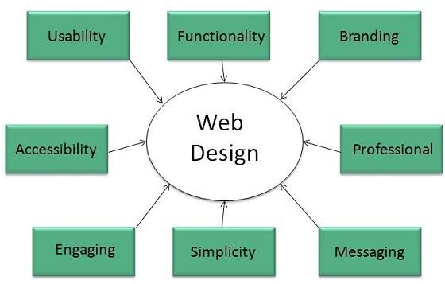

## Web Designing Tools

## **Photoshop CC, Illustrator CC**

## Web Page Anatomy

Containing Block

**Container** can be in the form of page’s body tag, an all containing div tag. Without container there would be no place to put the contents of a web page.

Logo

**Logo** refers to the identity of a website and is used across a company’s various forms of marketing such as business cards, letterhead, brouchers and so on.

**Navigation**

The site’s **navigation system** should be easy to find and use. Oftenly the anvigation is placed right at the top of the page.

Content

The content on a web site should be relevant to the purpose of the web site.

Footer

**Footer** is located at the bottom of the page. It usually contains copyright, contract and legal information as well as few links to the main sections of the site.

**Whitespace**

It is also called as **negative space** and refers to any area of page that is not covered by type or illustrations.

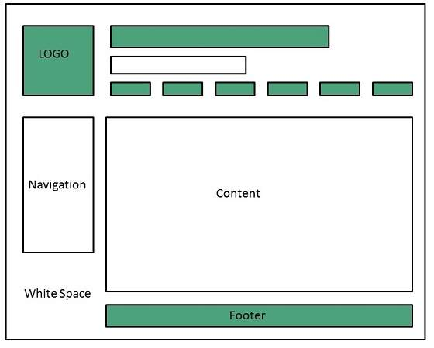

## Web design Mistakes

One should be aware of the following common mistakes should always keep in mind:

* Website not working in any other browser other internet explorer.
* Using cutting edge technology for no good reason
* Sound or video that starts automatically
* Hidden or disguised navigation
* 100% flash content.

**Web development**

**Web development** refers to building website and deploying on the web. Web development requires use of scripting languages both at the server end as well as at client end.

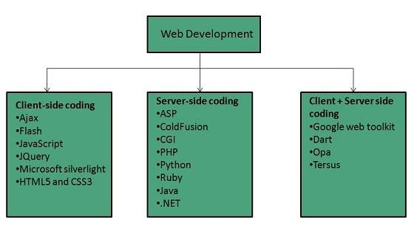

Before developing a web site once should keep several aspects in mind like:

* What to put on the web site?
* Who will host it?
* How to make it interactive?
* How to code it?
* How to create search engine friendly web site?
* How to secure the source code frequently?
* Will the web site design display well in different browsers?
* Will the navigation menus be easy to use?
* Will the web site loads quickly?
* How easily will the site pages print?
* How easily will visitors find important details specific to the web site?
* How effectively the style sheets be used on your web sites?

## Web Development Process

Web development process includes all the steps that are good to take to build an attractive, effective and responsive website. These steps are shown in the following diagram:

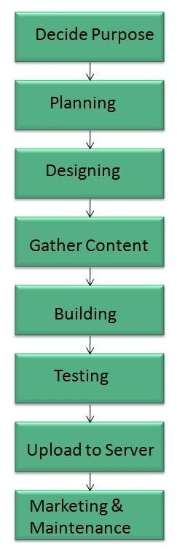

## Skills Required

For being a successful web developer, one should possess the following skills:

* Understanding of client and server side scripting.
* Creating, editing and modifying templates for a CMS or web development framework.
* Testing cross browser inconsistencies.
* Conducting observational user testing.
* Testing for compliance to specified standards such as accessibility standards in the client region.
* Programming interaction with javaScript, PHP, and Jquery etc.

**Websites Publishing**

Website publishing is the process of uploading content on the internet. It includes:

* uploading files
* updating web pages
* posting blogs

Website is published by uploading files on the remote server which is provided by the hosting company.